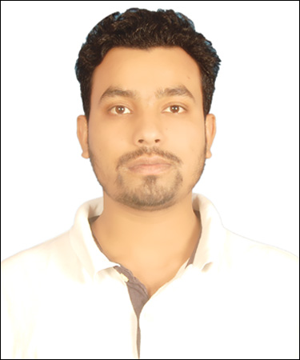
Present Address:
Sector-18, village- sarhaul
Opposite Siemens (Gurgaon)
PIN CODE- 122015

ARIF JAMAL
Diploma , MECHANICAL (AUTOMOBILE)
ENGINEERING
Contact No. : - 08565810360
E-mail:- jamal.aarif82@gmail.com

CAREER OBJECTIVE
To work in a firm with a professional work driven environment where I can utilize and apply my knowledge, skills which would enable me as a fresh graduate to grow while fulfilling organizational goals.

BASIC ACADEMIC CREDENTIALS

Qualification | School/College | Board/University | Passing year | Percentage
Diploma, Mechanical(Automobile) Engineering | Integral | Integral University,Lucknow | 2016 | 69.69%
Intermediate | Gandhi Inter College,Ballia | UP Board | 2012 | 68.6%
Matriculation | Adarsh Shikhsha Niketan,Ballia | UP Board | 2010 | 47.83%

EXPERIENTIAL LEARNING (SUMMER INTERNSHIP PROGRAM)

Company Name | Project Title | Duration
North Eastern Railway, Workshop,Gorakhpur | Maintananc of Rail Engine, Electric Loco Shed. | 10/06/2015 to 09/07/2015

PROJECTS REPORT

- Magnetic Retarding System.

ACHIEVEMENTS.

- Participated in Quizzical competiton held at Varsity Premises.
- Participated in Nationalism Quiz held at Integral University.

INTERPERSONAL SKILL

  - Ability to rapidly build relationship and set up trust.
  - Confident and Determined
  - Ability to cope up with different situations.

PERSONAL DETAIL
- Name :- ARIF JAMAL
- Father’s Name :- KALAM ANSARI
- Permanent Address :- VILL+POST, Usraila
DIST- Ballia ( U P )
PIN CODE- 277124
- Date of Birth :- 05 Julay 1996
- Language Known :- English & Hindi
- Marital Status :- Single
- Nationality :- Indian
- Interest & Hobbies :- Internet browsing, Reading Books,
Reading science digests.

DECLARATION

I do hereby declare that the above information is true to the best of my knowledge.

Place: ARIF JAMAL
Date: (Signature)

